Development and Implementation of Cloud Platform for IoT Devices

Mrs. Gayathri R  Electrical and Electronics Engineering  MVJ College of Engineering  Bengaluru, India  gayathri.r@mvjce.edu.in | Chetan C  Electrical and  Electronics Engineering  MVJ College of Engineering  Bengaluru, India  Chetangowda1521@gmail.com | Shruthi K  Electrical and Electronics Engineering  MVJ College of Engineering  Bengaluru, India  charusha16@gmail.conm
 | Sumanth M  Electrical and Electronics Engineering  MVJ College of Engineering  Bengaluru, India  sumanth.m70@gmail.com | Vinay K S  Electrical and Electronic Engineering  MVJ College of Engineering  Bengaluru, India  vinayksgowda1108@gmail.com

Abstract— This project aims at controlling electrical loads with the help of Node mcu ESP8266 using our web application. This project helps at reducing the wastage of electricity. By using the web application it helps us to remotely access loads or devise and thus implement wireless technology. The design involves the use of Node mcu and the applications are connected using wires and breadboard. The communication between the platform and Node mcu is wireless. The authentication generation will ensure only authorized users access. This IoT system designed will help control electrical loads from anywhere through wireless technology.

Keywords— IoT, Node mcu ESP8266, Web
- INTRODUCTION

The Internet of Things (IoT) is a rapidly growing network that encompasses everyday objects such as industrial machines and consumer home appliances. These objects are designed to share data and complete tasks [1]. The goal of IoT is to bring together everything in our world under a common infrastructure, providing us with control over the objects around us while also keeping us informed about their status.[2]. This concept is a new and revolutionary one, driven by advancements in mobile devices, networking, and cloud technologies The project aims to leverage the numerous benefits of IoT by enabling device control through web applications on mobile phones [3 Automation has become an essential aspect of modern life, reducing human effort and making daily tasks simpler and easier to manage [4].
The objective of the project is to create a web-based interface for controlling electrical appliances. Its main focus is to develop and implement an IoT platform that enables communication, data transfer, device management, and application functionality. [5] The platform enables wireless control of various devices, including lights, fans, air conditioners, televisions, security cameras, electronic computer systems and other equipment’s.[6]
The web application serves as a middleware that mediates between the user and the server. The user's input is transmitted to the server and, subsequently, the microcontroller (ESP8266) receives the data in the form of a text file sequence [7]. The web application serves as a middleware that mediates between the user and the server. The user's input is transmitted to the server and, subsequently, the microcontroller (ESP8266) receives the data in the form of a text file sequence[8]. Communication is a fundamental aspect of smart devices, which can interact with each other, exchange data, and perform tasks without human intervention. These devices are equipped with electronics, sensors, software, and networking capabilities that enable seamless communication [9].
There are three primary models of communication in IoT:
a) Device-to-Device Communications, wherein two or more devices establish a direct connection and communicate with each other.
b) Device-to-Cloud Communications, wherein the IoT device connects directly to an internet cloud service, such as an application service provider, to exchange data and control message traffic
c) Device-to-Gateway Model, wherein an application software operates on a local gateway device, serving as an intermediary between the device and the cloud service. The gateway provides security and additional functionality such as data or protocol management. [10]
Device management is a crucial aspect that enables efficient monitoring and control of IoT devices. It involves bulk registering and deploying connected devices, organizing them into relevant groups, logging device activities, remotely managing and updating devices, and creating customizable dashboards for centralized device control [11].
The primary goal of the IoT platform is to eliminate the barriers among various layers and integrate them to achieve effective and smooth collaboration [12].
The IoT platform facilitates a flexible connection between hardware and the cloud while ensuring security measures and comprehensive data processing capabilities [13].
The IoT platform facilitates a flexible connection between hardware and the cloud while ensuring security measures and comprehensive data processing capabilities [14]. User need to provide their username and password for in order to retrieve data from the server. The registration process of IoT devices includes authorization and to ensure security [15]. A web-based interface is provided by the IoT platform for registered users to add and manage their IoT devices. To access the current status of the devices, a web application has been developed that connects to the server where the device data is stored [16].

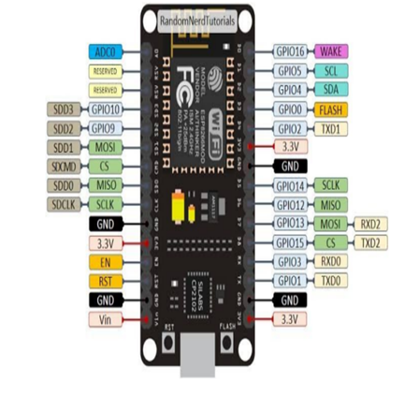

Fig 1. Nodemcu esp32

NodeMCU is an open-source development board based on the ESP8266 Wi-Fi module. It combines a microcontroller unit (MCU) with built-in Wi-Fi connectivity, making it ideal for Internet of Things (IoT) projects. NodeMCU provides a simple and inexpensive way to connect your devices to the internet and control them remotely. It is programmable using the Lua scripting language or Arduino IDE, and offers a range of GPIO pins for interfacing with sensors, actuators, and other electronic components.

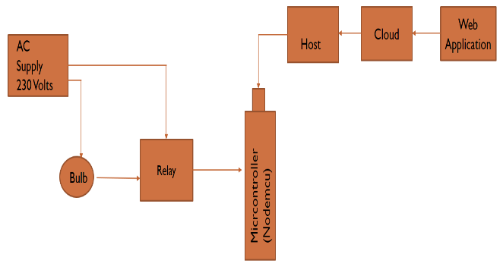
Figure 2. Methodology of the proposed system

This methodology consists of Ac supply which is been connected to the bulb and the relay paralelly. This is been connected to micro controller which is been connected to the host where this acts as the mediator between the cloud and the nodemcu. The web application gives the user to take input and the following inputs are been converted to actions. Output, resulting in higher efficiency and improved performance.

- PROPOSED SYSTEM

This paper presents a proposed system for the development and implementation of a cloud platform specifically designed for IoT devices. The rapid growth of IoT technologies has resulted in an increased need for scalable and reliable cloud solutions to manage and analyse the massive volumes of data generated by these devices. The proposed system aims to address these challenges by leveraging cloud computing capabilities to provide a robust and efficient platform for IoT device management and data processing. This paper outlines the key components and functionalities of the proposed system, highlighting its potential benefits and discussing the implementation strategies.

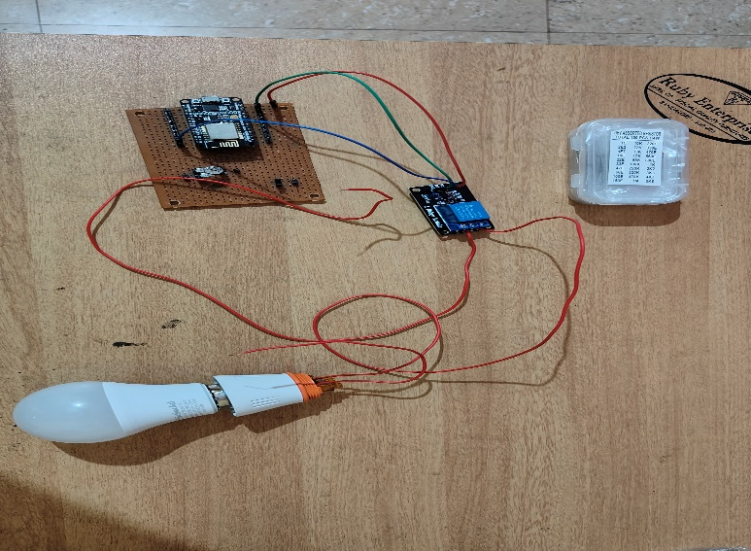

This circuit consists of various devices such as relay module, LED bulb, various resistors, fuse, nodemcu etc. Here the switching of the bulb is been automatically controlled from various geographical locations as per the above shown diagram. Enhancement of the above circuit can be done by including other devices such as tube lights and devices.
An IoT (Internet of Things) platform typically consists of various hardware and software components that enable the connection, communication, and management of IoT devices and data IoT devices are often powered by microcontrollers or microprocessors, which serve as the brain of the device. They control the operations of the device, handle data processing, and manage communication with other devices or the IoT platform.
IoT platforms typically provide user interfaces and applications to monitor and control IoT devices. These interfaces can be web-based dashboards, mobile applications, or even voice-based interfaces.
Users can interact with the devices, view real-time data, set up automation rules, and receive alerts or notifications.

- WEB APPLICATION
Sign in:
The login form/sign-in form is crucial for accessing websites or web applications and ensuring data security. Upon successful login, the control panel form is displayed, enabling users to modify the switch status.
The purpose of a login page is to grant users access to an application or website by providing their login credentials, such as a username and password.
The Login page requires the user to enter their credentials, which are then verified by the application. After successful validation, the user gains access to the secure part of the application.

Sign Up:

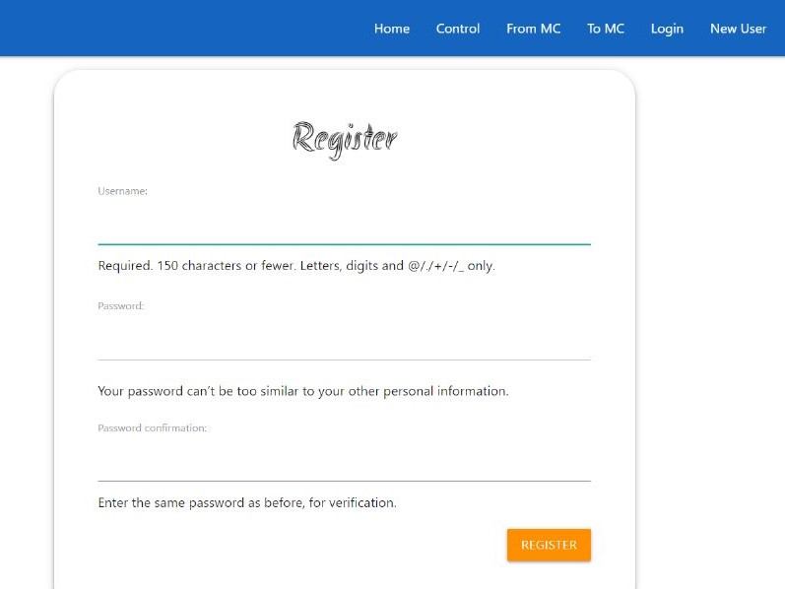

This feature offers users a convenient and streamlined registration process without the need to create a new account and fill in all the required information. By simply clicking on the sign-up button, users can easily connect with the application, which makes them feel more at ease.
Rule for creating an account:
- The password should be atleast 8 characters long, but having more characters can provide better security.
- Using a combination of uppercase letters, lowercase letters, numbers and symbols can make the password more complex and secure. The password should be atleast 8 characters long, but having more characters can provide better security.
- Using a combination of uppercase letters, lowercase letters, numbers and symbols can make the password more complex and secure.
- Avoid using words found in dictionary.
- The new password must be significantly different from the previous password to ensure better security.
- Choose a username that is easy to remember but difficult to guess.
- To create username, avoid using easily guessable numbers such as your address or date of birth, and do not use your social security or ID number.
Upon submitting the sign-up form, a confirmation email will be sent to the email address provided.

Home:
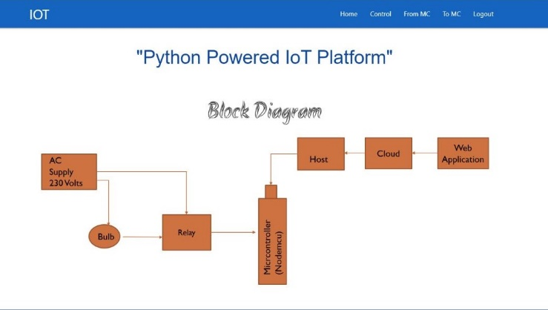
The first impression of your load control web application is crucial as it can influence users' perception of it, either positively or negatively. The application's interface has become the primary means through which users interact with it.
A website with a well-thought-out design can create a positive impression on potential clients or customers, increase lead generation, and drive conversions. Additionally, it provides a great user experience, making it easy for visitors to access and navigate the site.
The home page includes links to the sign-up and login forms, as well as information about the team. These links allow the user to easily access the corresponding pages or information
Control Switch Panel:
The control panel serves as an intermediary between the host computer and the peripheral devices, managing their functions and ensuring effective communication between them.

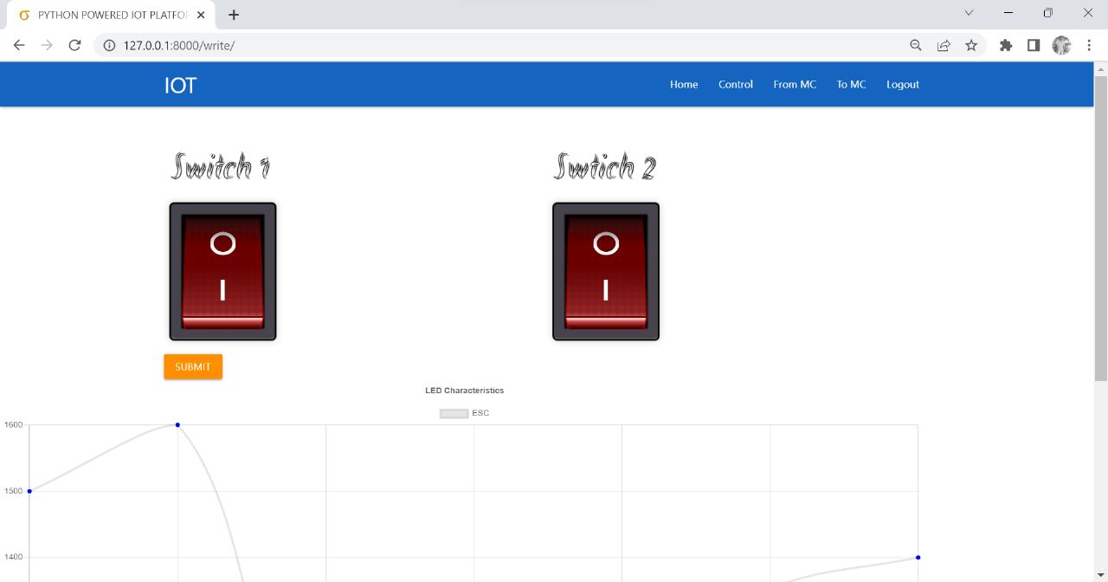

One of the primary roles of the control panel is to consolidate all connections to the peripheral devices, enabling the user to easily access and manage them from a single location. Another important function of the control panel is to provide power to the peripheral devices, as required.
The control switches present in the panel play a crucial role in sending data to the microcontroller, which processes the information and executes the required actions. The switches are designed to convert the user's input into a text file format that can be easily processed by the microcontroller. Moreover, the submit button is conveniently placed under the switches, allowing the user to submit their desired changes with ease. Once the submit icon is clicked, the status of the load is changed to the required state of the switch, enabling the user to effectively control the connected peripheral devices.

Data sent to microcontroller:
The NodeMCU ESP8266 is a popular IoT (Internet of Things) development board that can be programmed to send and receive data wirelessly. It features built-in Wi-Fi capabilities, making it easy to connect to the internet and exchange information with other devices or cloud services.
To establish a connection between the NodeMCU and a server using protocols like HTTP or MQTT. With HTTP, we can send data to the NodeMCU by making HTTP POST requests with the desired payload.
To send data to the NodeMCU, we used programming language Python.This language provides libraries and APIs specifically designed for working with the NodeMCU ESP8266, simplifying the process of sending and receiving data.
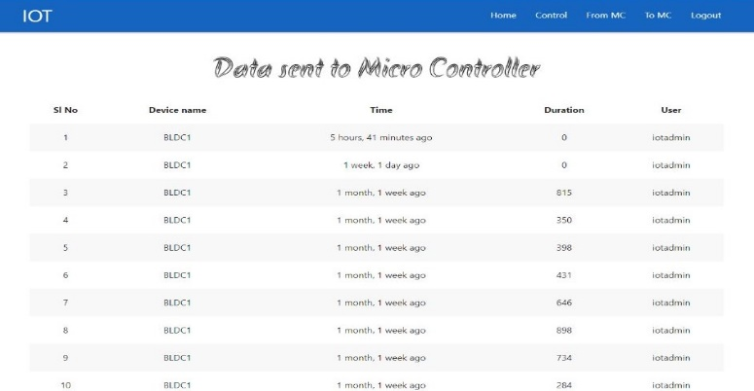

Data received from microcontroller:

To receive data on the NodeMCU ESP8266, you can implement various communication protocols such as HTTP or MQTT. With HTTP, we can set up a web server on the NodeMCU and handle incoming requests. This allows us to receive data sent as part of HTTP POST or GET requests. Once received, we can process and utilize the data according to our application's requirements.
By using python as the programming language, the language provide libraries and APIs that simplify the implementation of communication protocols and data processing on the board.

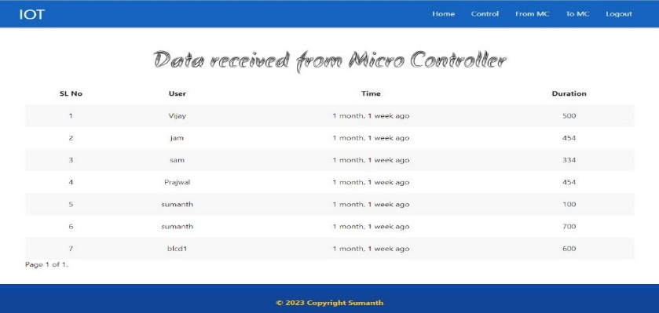

- CONCLUSION AND IMPROVEMENT

The IoT cloud platform is a highly promising and transformative technology that has the potential to revolutionize various industries. The IoT cloud platform serves as a centralized infrastructure that enables seamless integration, management, and analysis of vast amounts of data collected.
The integration of cloud computing capabilities with IoT devices and sensors enables advanced data analytics and machine learning techniques. This empowers organizations to derive valuable insights, identify patterns, and make data-driven decisions. By harnessing the power of big data and predict maintenance needs, and even create personalized customer experiences.
In conclusion, the IoT cloud platform represents a game-changing technology that offers numerous benefits to businesses across industries. Its ability to connect, analyse, and derive insights from a wide range of devices and sensors presents exciting opportunities for innovation and optimization. However, it is crucial for organizations to carefully evaluate their requirements, choose reliable and secure IoT cloud platforms, and address any potential challenges to fully.

References
- Miguel Angel López Peña Innovation and Development Department. Sistemas Avanzados de Tecnología, S.A. (SATEC) Madrid, Spain, 2019 IEEE 5th World Forum on Internet of Things (WF-IoT)
- Luca Calderoni, Antonio Magnani, Dario Maio, Dept. of Computer Science and Engineering Universita di Bologna ` Cesena, Italy,2019 IEEE 5th World Forum on Internet of Things (WF-IoT)
- Aayush Doshi1 , Deep Vakharia2 , Yashraj Rai3 1, 2, 3Department of Information Technology, St Francis Institute of Technology,Mumbai University
- Sirsath N. S, Dhole P. S, Mohire N. P, Naik S. C & Ratnaparkhi N.S Department of Computer Engineering, 44, Vidyanagari, Parvati, Pune-411009, India University of Pune, “Home Automation using Cloud Network and Mobile Devices”.
- Deepali Javale, Mohd. Mohsin, Shreerang Nandanwar “Home Automation and Security System Using Android ADK” in International Journal of Electronics Communication and Computer Technology (IJECCT) Volume 3 Issue 2 (March 2013).
- Charith Perera, Student Member, IEEE, Arkady Zaslavsky, Member, IEEE, Peter Christen,and Dimitrios Georgakopoulos, Member, IEEE “Context Aware Computing for The Internet of Things: A Survey”. IEEE
- Charith Perera_y, Arkady Zaslavskyy, Peter Christen_ and Dimitrios Georgakopoulosy Research School of Computer Science, The Australian National University,Canberra, ACT 0200, Australia yCSIRO ICT Center, Canberra, ACT 2601, Australia ” CA4IOT: Context Awareness for Internet of Things”
- .P.Pande, Prof.Pravin Sen, “Review On: Home Automation System For Disabled People Using BCI” in IOSR Journal of Computer Science (IOSR-JCE) e-ISSN: 2278-0661, p-ISSN: 2278-8727 PP 76-80
- Basil Hamed, “Design & Implementation of Smart House Con-trol Using LabVIEW” at International Journal of Soft Computing and Engineering (IJSCE) ISSN: 2231-2307, Volume-1, Issue-6, January 2012
- Basma M. Mohammad El-Basioni1, Sherine M. Abd El-kader2 and Mahmoud Abdelmonim Fakhreldin3, “Smart Home Design using Wireless Sensor Network and Biometric Technologies” at Volume 2, Issue 3, March 2013
- Rosslin John Robles and Tai-hoon Kim, “Review: Context Aware Tools for Smart Home Development”, International Journal of Smart Home, Vol.4, No.1, January, 2010
- Hitendra Rawat, Ashish Kushwah, Khyati Asthana, Akanksha Shivhare, “LPG Gas Leakage Detection & Control System”, National Conference on Synergetic Trends in engineering and Technology (STET-2014) International Journal of Engineering and Technical Research ISSN: 2321-0869, Special Issue
- Nicholas D., Darrell B., Somsak S., “Home Automation using Cloud Network and Mobile Devices”, IEEE Southeastcon 2012, Proceedings of IEEE.
- Chan, M., Campo, E., Esteve, D., Fourniols, J.Y., “Smart homescurrent features and future perspectives,” Maturitas, vol. 64, issue 2, pp. 90-97, 2009
- Das, S.R., Chita, S., Peterson, N., Shirazi, B.A., Bhadkamkar, M., “Home automation and security for mobile devices,” IEEE PERCOM Workshops, pp. 141-146, 2011
- S.D.T. Kelly, N.K. Suryadevara, S.C. Mukhopadhyay, “To-wards the Implementation of IoT for Environmental Condition Monitoring in Homes”, IEEE, Vol. 13, pp. 3846-3853, 2013
- Rajeev Piyare “Internet of Things: Ubiquitous Home Control and Monitoring System using Android based Smart Phone” International Journal of Internet of Things 2013, 2(1): 5-11 DOI: 10.5923/j.ijit.20130201.02
- R. Piyare and M. Tazil, Bluetooth based home automation system using cell phone, in Consumer Electronics (ISCE), 2011 IEEE 15th International Symposium on, 2011, pp. 192-195

